| Course name | Numerical Modelling & Simulation in Scilab Xcos |
| --- | --- |
| **Lesson name** | **Numerical Modelling of Student Electric Racing Vehicle using Drive Cycle data in Scilab-Xcos** |
| **Lesson objective** | **Practice blocks &** **acquaint to use GUI of Scilab-Xcos** |
| Created by | THATIREDDY HEMANTH |

**Problem statement:** Model Student Electric Racing Vehicle for Drive Cycle in Scilab Xcos to plot the Wheel Torque, Wheel Speed, Motor Torque, Motor Speed and Battery Current in Scilab-Xcos.

**Drive Cycle Graph:**

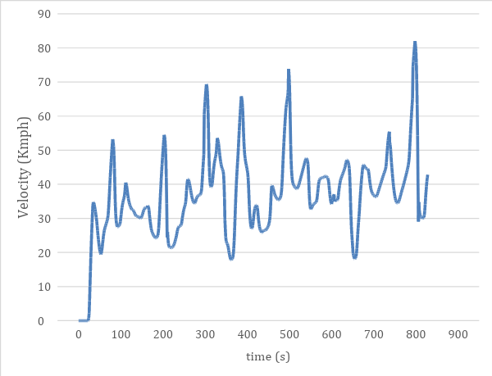

**Model Inputs:**

| **Sl No** | **Parameter** | **Value** | **Units** |
| --- | --- | --- | --- |
|  | 1. **Chassis** |  |  |
|  | 1. Coefficient of rolling resistance | 0.015 |  |
|  | 1. Gross Vehicle Mass | 320 | Kg |
|  | 1. Gravity constant | 9.81 | m/s |
|  | 1. Grade Angle | 0 | degree |
|  | 1. Velocity | From the Drive Cycle data | Kmph |
|  | 1. Frontal Area | 1.8585 | m^2 |
|  | 1. Air Density | 1.225 | Kg/m^3 |
|  | 1. Drag Coefficient | 0.15 |  |
|  | 1. Radius of wheel | 0.2286 | m |
|  | 1. **Transmission** |  |  |
|  | 1. Gear Ratio | 15 |  |
|  | 1. Transmission Efficiency | 85 | % |
|  | 1. **Motor** |  |  |
|  | Motor Efficiency | 90 | % |
|  | 1. **Battery** |  |  |
|  | 1. Motor Controller Efficiency | 85 | % |
|  | 1. Battery Voltage | 540 | V |
|  | 1. Drive cycle distance (One Lap) | 0.825 | Km |
|  | 1. No of laps | 12 | Km |
|  | 1. Battery Initial SOC | 100 | % |
|  | 1. **Cell** |  |  |
|  | 1. Cell Voltage | 3.7 | V |
|  | 1. Cell Capacity | 6.6 | Ah |

**Program:**

| 1. **To Import Acceleration Data:** | 1. **To define all input parameters:** |
| --- | --- |
| //Importing Drive_cycle data  data =csvRead("RT New.csv")  //Drive_cycle data  Drive_cycle.time = data(3:831,1)  Drive_cycle.values = data(3:831,2) | //Vehicle Dynamics  //Radius of the wheel  Rw = 0.2286 //m  //Coefficienct of rollign resistance  Crf = 0.015  //Gross Vehicle Mass  GVM = 320 //Kg  //Gravitational Constant  g = 9.81  //Gross Vehicle Weight  GVW = GVM*g  //Drag Coefficienct  Cd = 0.15  //Frontal Area  Area=1.8585  //Transmission  //Gear Ratio  Gear_Ratio = 15  //Transmission Efficiency  Neff = 0.85 |

**Results:**

| **Rolling Force:** | **Gradeability Force:** |
| --- | --- |
|  |  |
| **Aerodynamic Force:** | **Acceleration Force:** |
|  |  |
| **Wheel Speed:** | **Wheel Torque:** |
|  |  |
| **Motor Speed:** | **Motor Torque:** |
|  |  |
| **Motor Power:** | **Battery Power:** |
|  |  |
| **Battery Current:** | **Battery SOC:** |
|  |  |
| **Battery C-rate:** |  |
|  |  |

**Conclusion:**

| **Sl No** | **Parameters** | **Values** | **Units** |
| --- | --- | --- | --- |
|  | **Chassis** |  |  |
|  | * Rolling Force | 47.088 | N |
|  | * Gradeability Force | 0 | N |
|  | * Maximum Aerodynamic Force | 87.555 | N |
|  | * Maximum Acceleration Force | 10731.973 | N |
|  | * Maximum Wheel Speed | 945.927 | Rpm |
|  | * Maximum Wheel Torque | 2472.118 | Nm |
|  | **Motor** |  |  |
|  | * Maximum Motor Speed | 14188.912 | Rpm |
|  | **Motor Torque** |  |  |
|  | * Nominal Motor Torque | 193.891 | Nm |
|  | **Motor Power** |  |  |
|  | * Nominal Motor Power | 213753.46 | W |
|  | **Battery** |  |  |
|  | * Power per Km | 240.5 | Wh/Km |
|  | * Vehicle Range | 9.9 | Km |
|  | * Battery Capacity in Ah | 4.4 | Ah |
|  | **Cell** |  |  |
|  | * Cell Voltage | 3.7 | V |
|  | * Cell Capacity | 6.6 | Ah |
|  | **No of cells** | 1p&146s = 147 cells |  |
|  | **Battery Power** |  |  |
|  | * Nominal Battery Power | 251474.66 | W |
|  | **Battery Current** |  |  |
|  | * Nominal Battery Current | 465.69 | A |
|  | **Battery C-rate** |  |  |
|  | * Nominal Battery Discharge C-rate | 105.83 | C |
|  | * State of Charge | 100 | % |